Supplier screen UI/UX
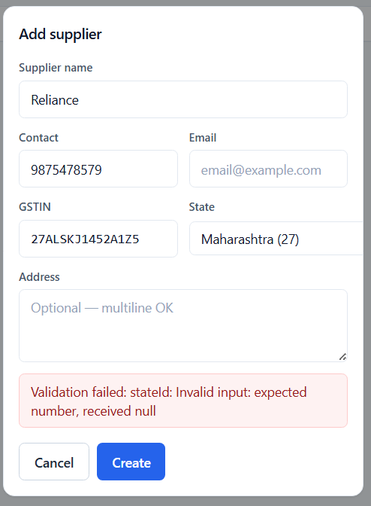

Lock BOM & Edit/delete with Admins Password – if in use can not delete
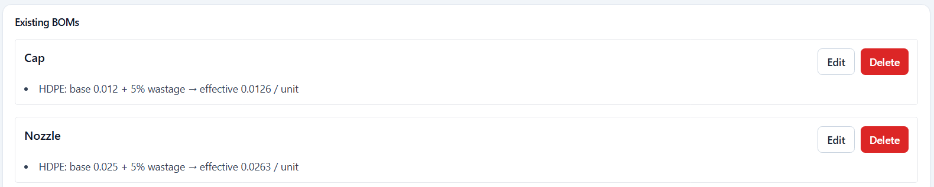

RM Purchase – Work on UI/UX
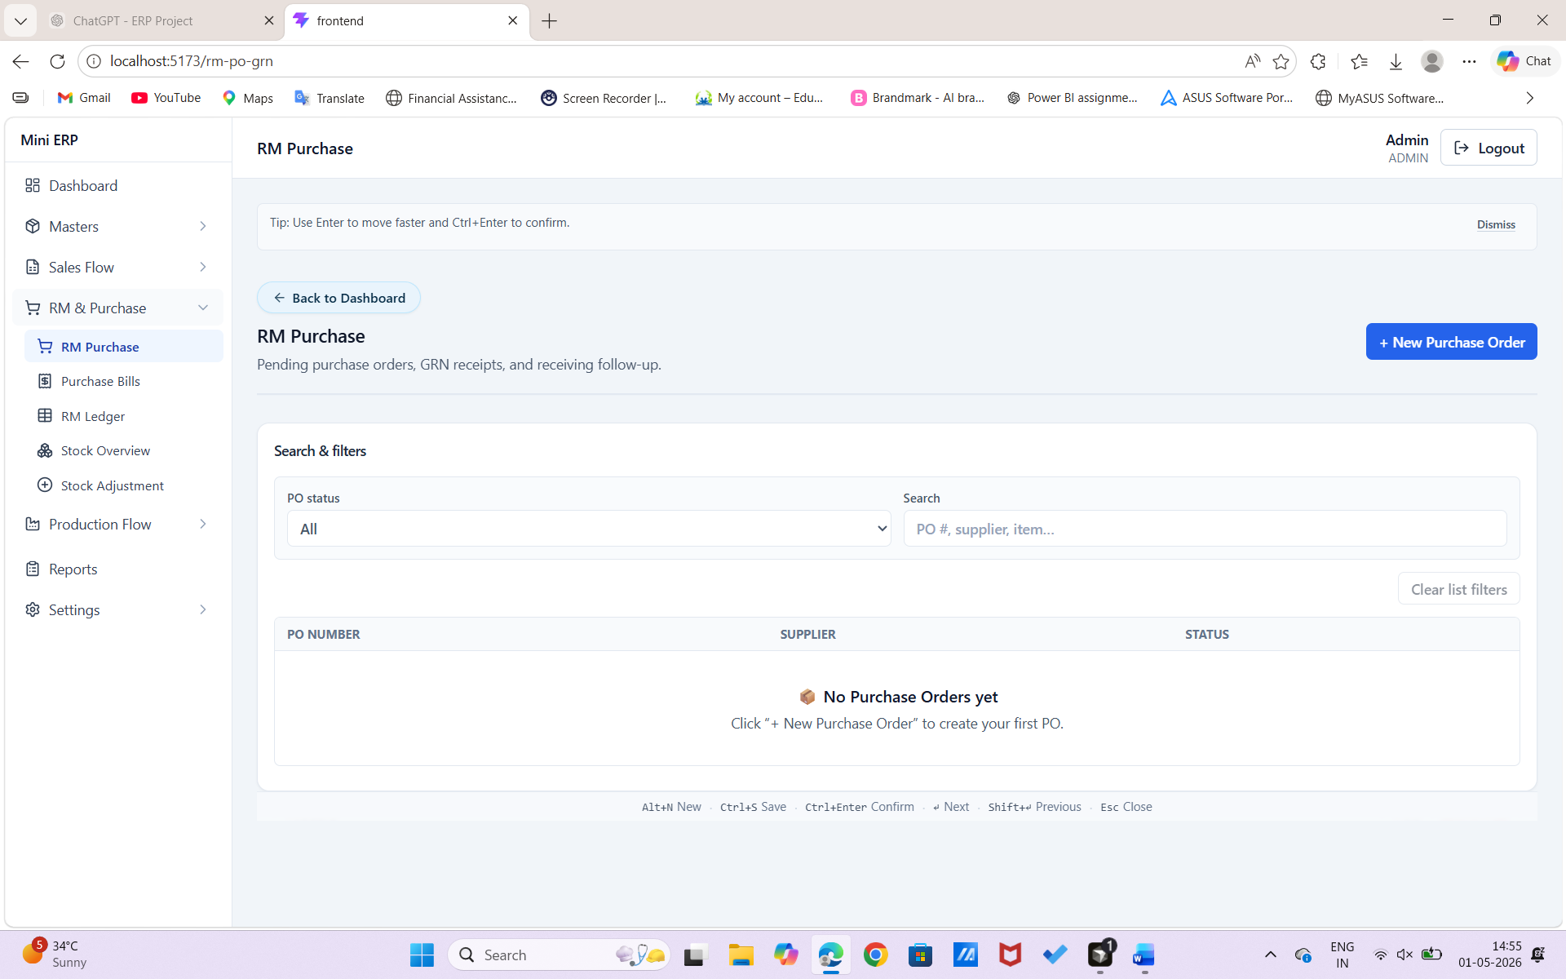
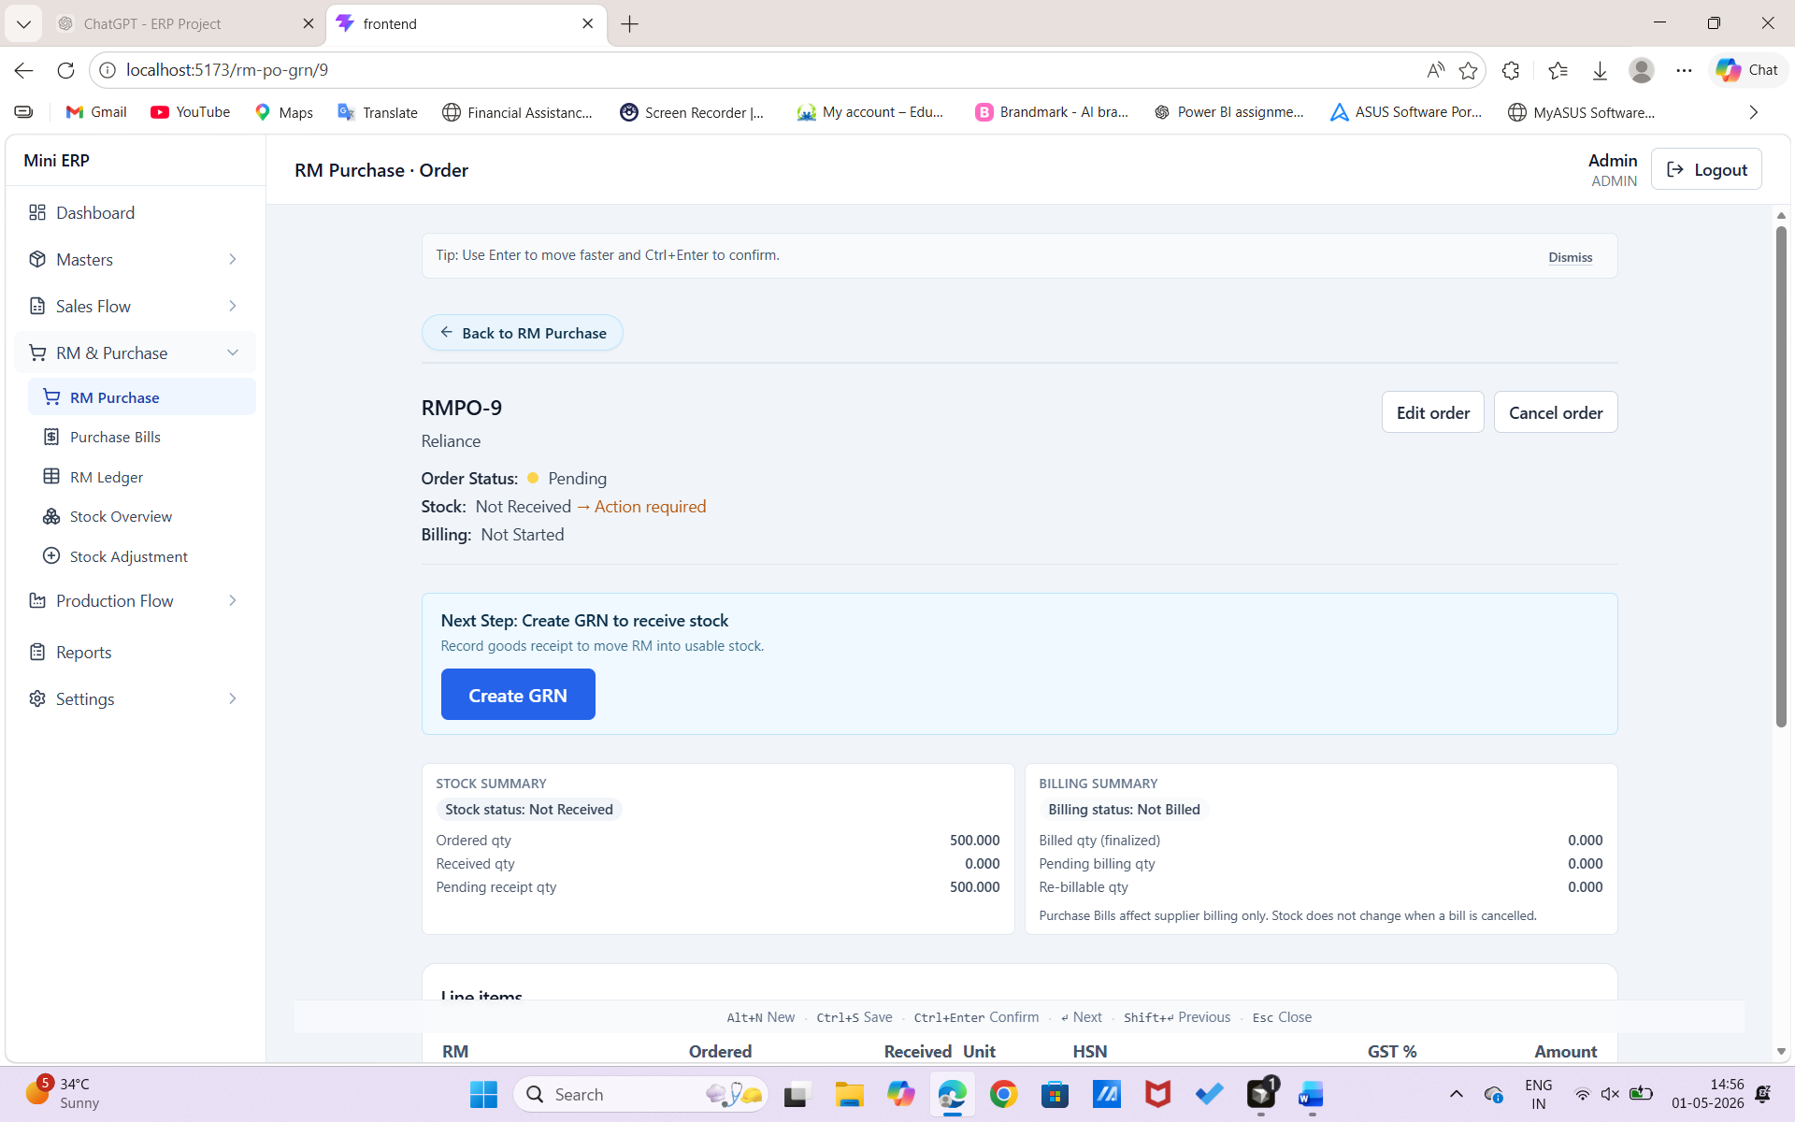
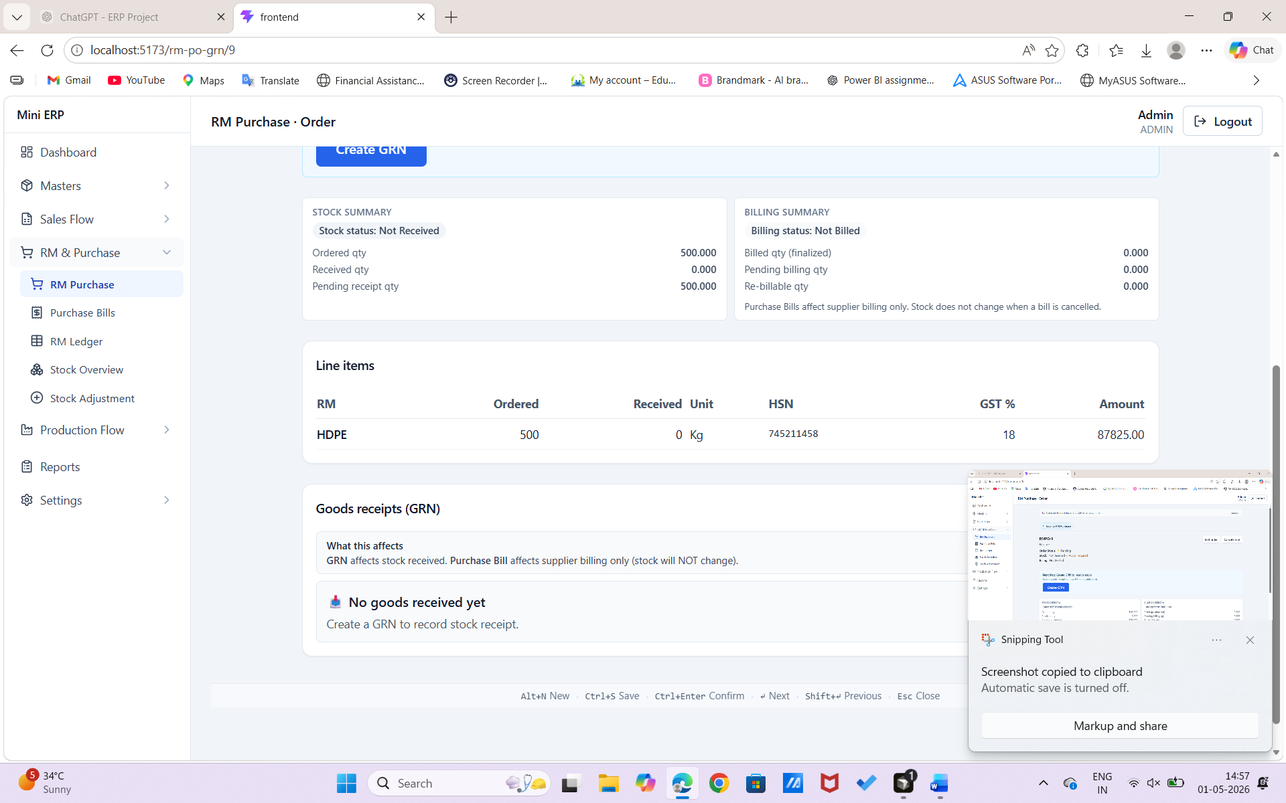

GRN – Work on UI/UX
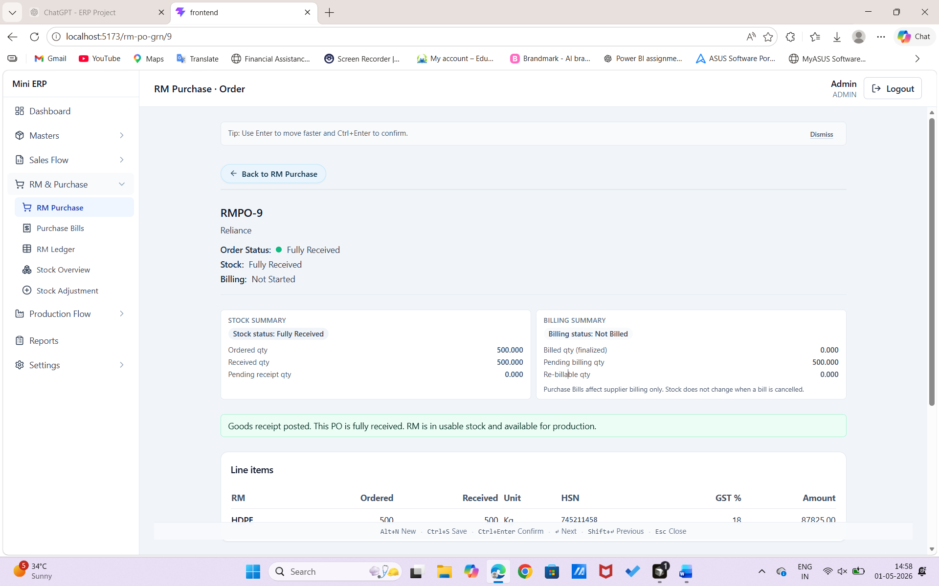

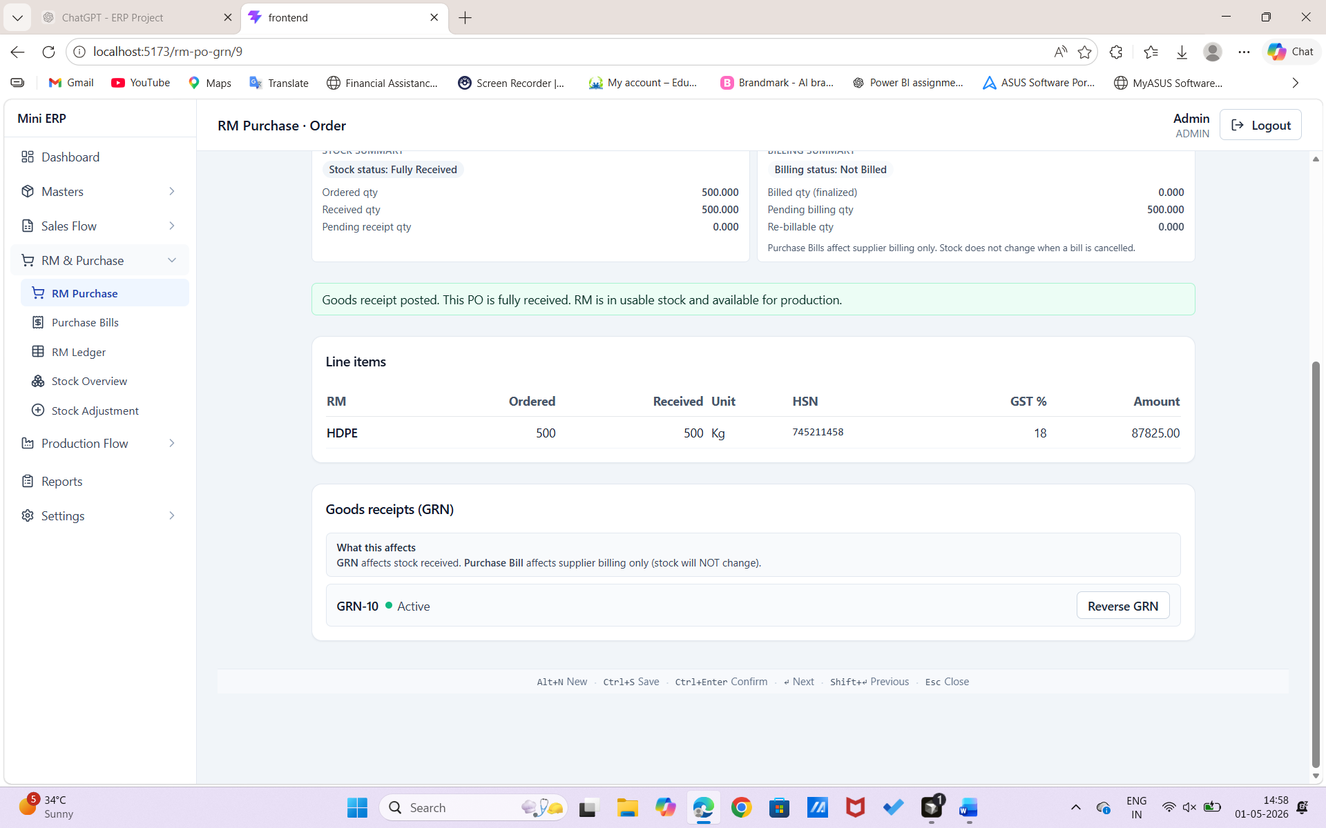

GRN DATE?

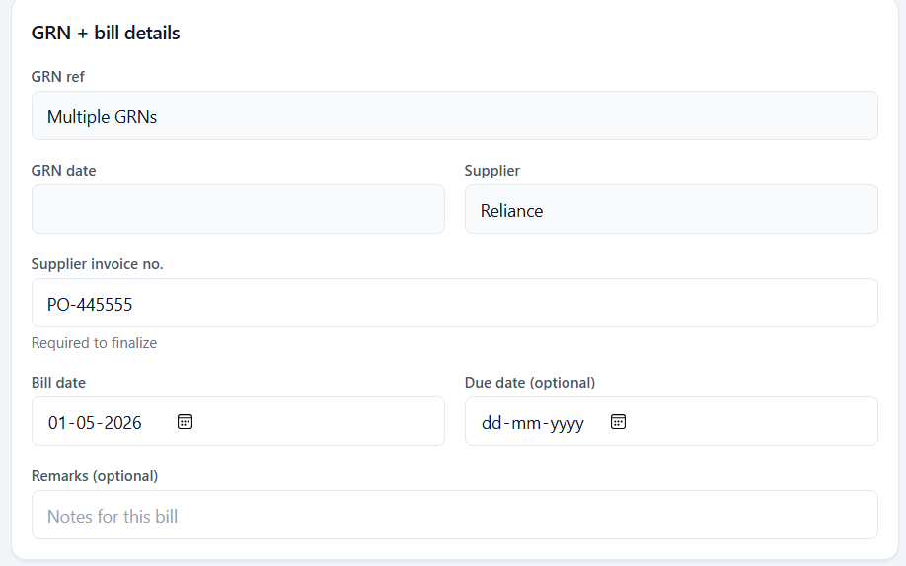

Planning
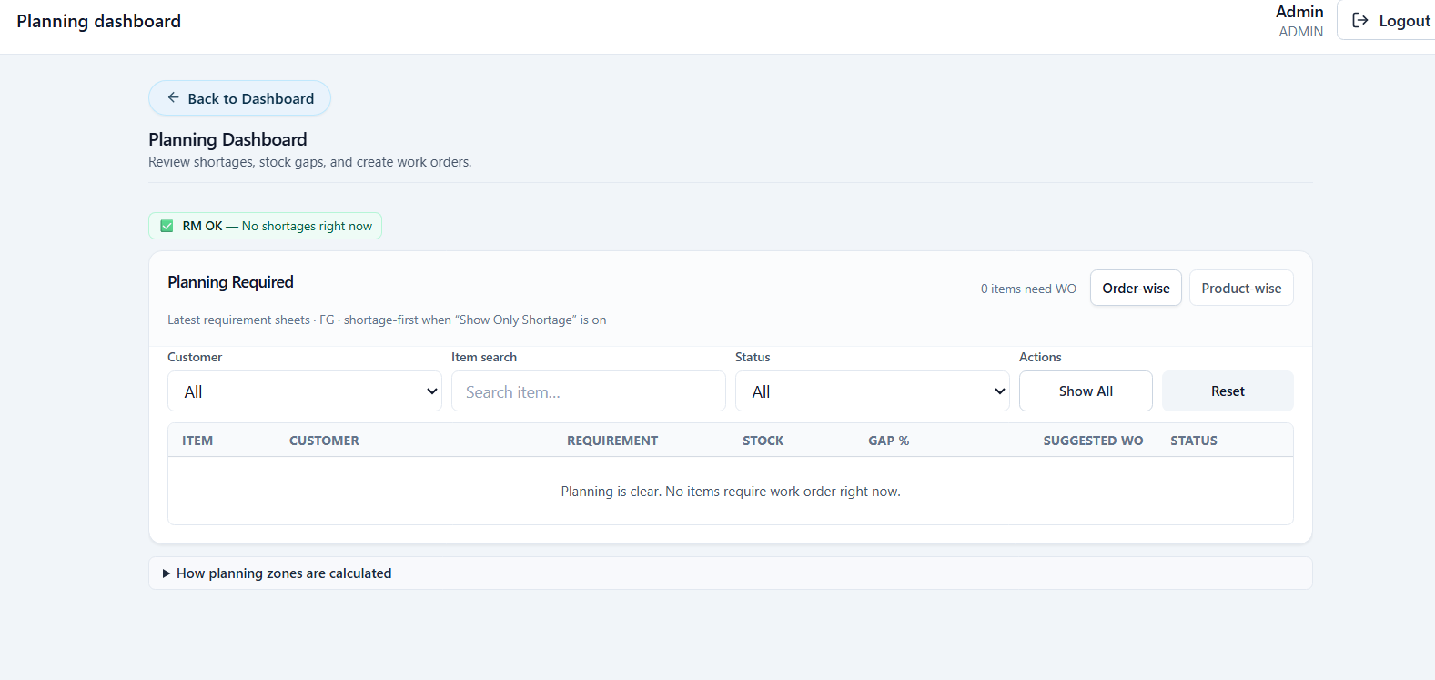

Prod Planning - ?
Keep One Only

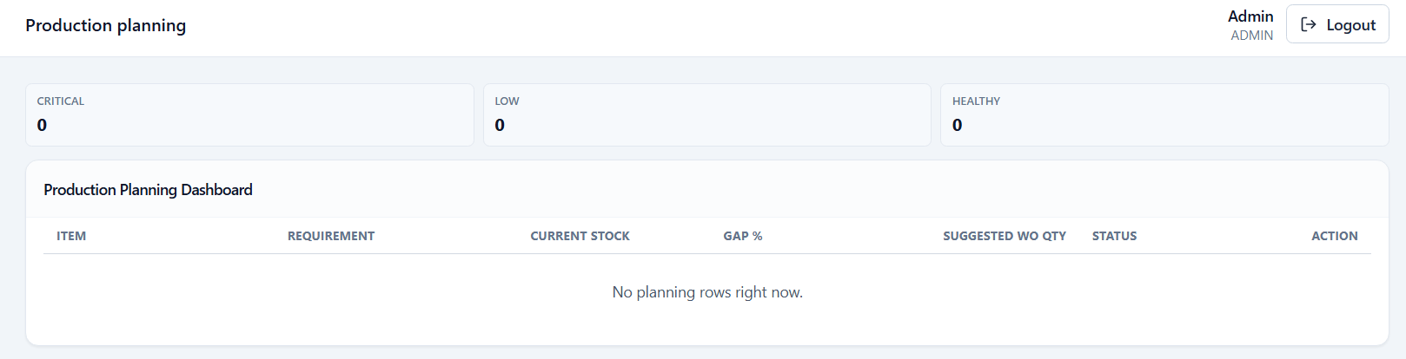

Make Customer PO Mandatory
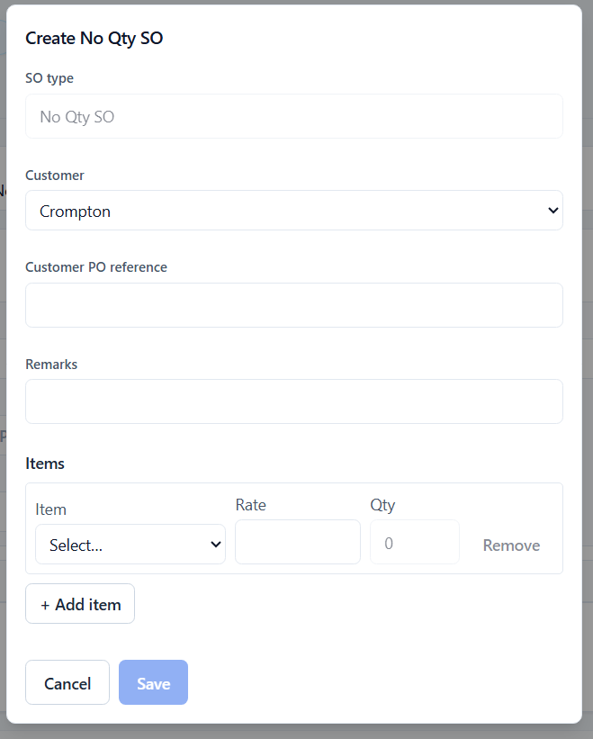

I have to fill this RS then why Proceed to Dispatch?
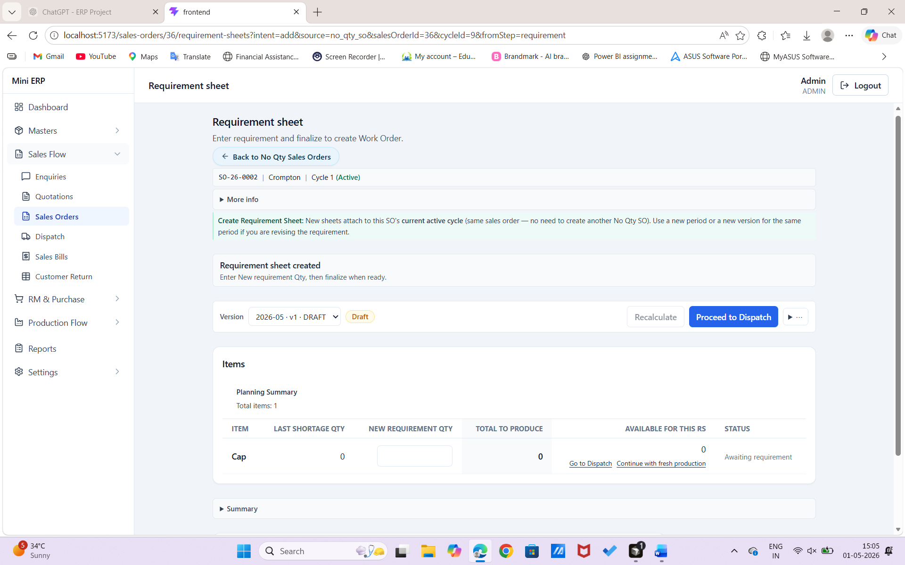

Production Screen – too much space on top & Left Side
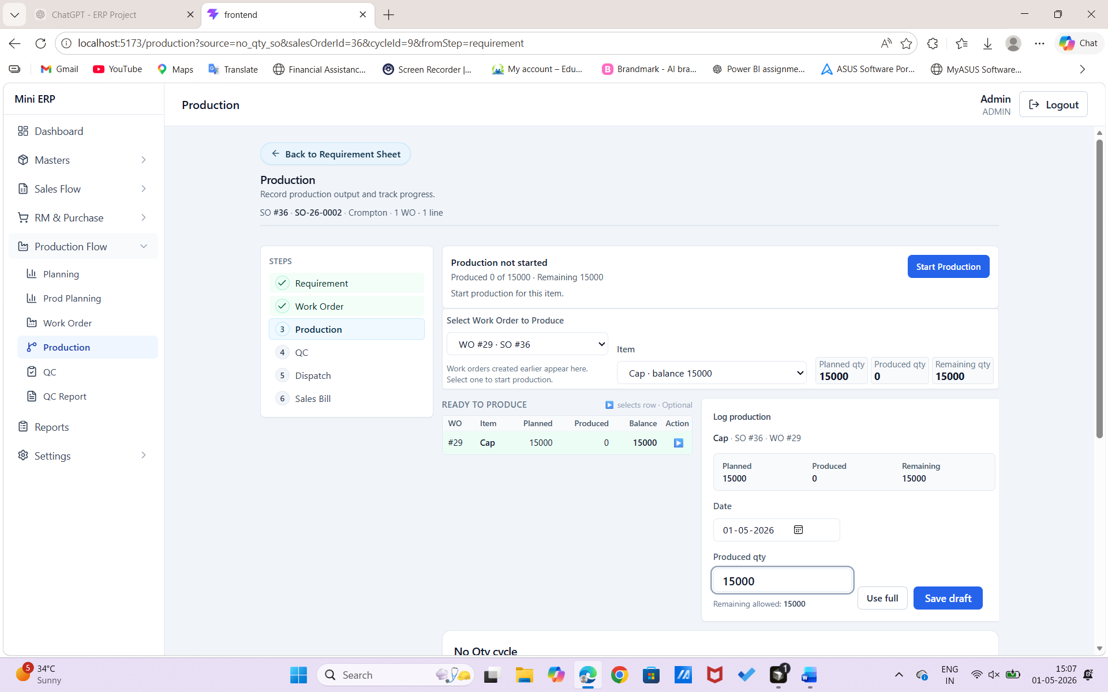

After saving draft go down for approve
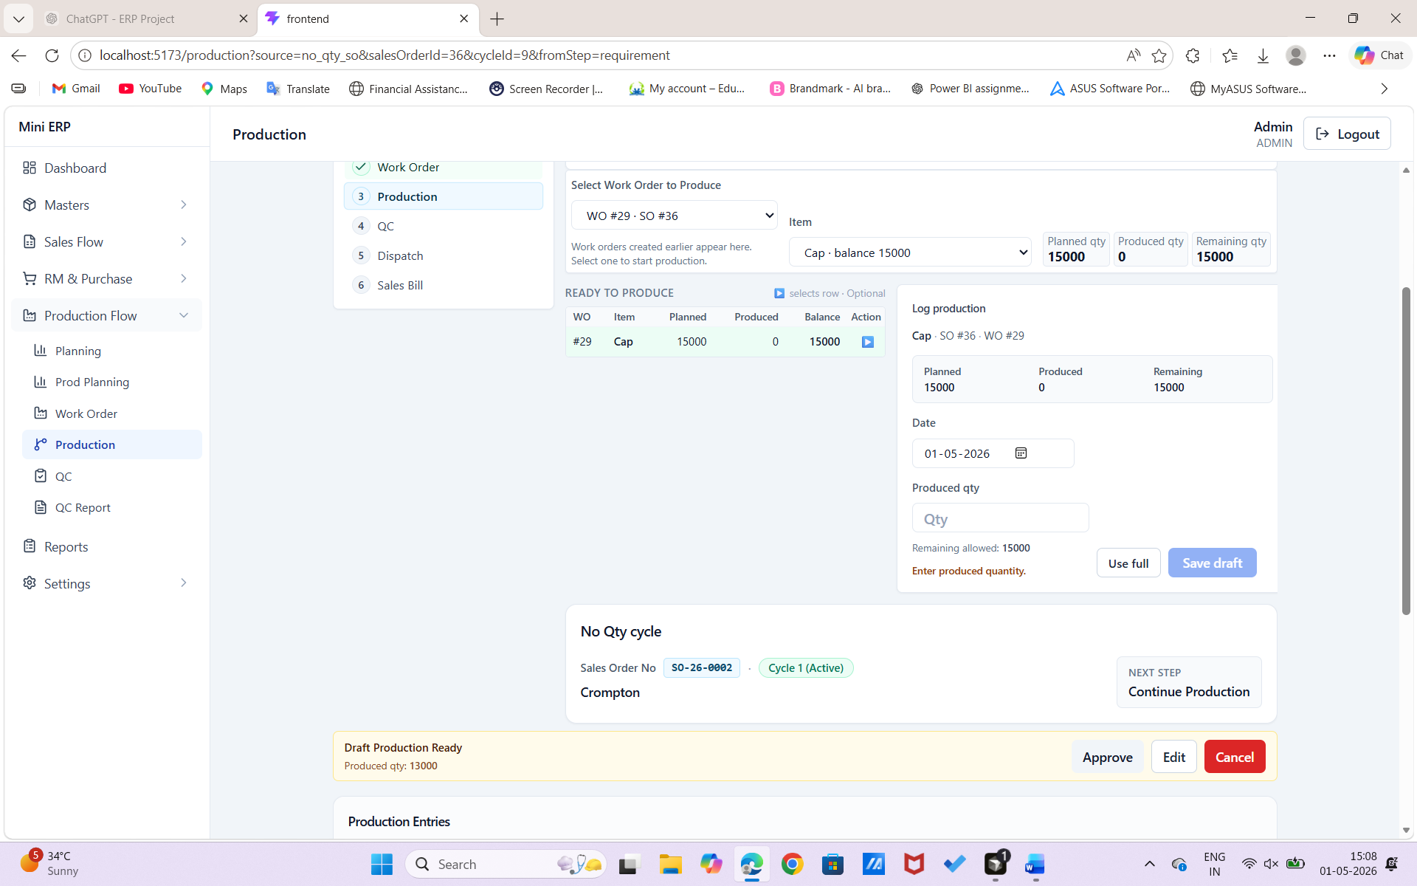

Why continue Production, Move to QC & Go to QC – very confusing after approving

When I use winodws back button why it forcing me to produce remaining?
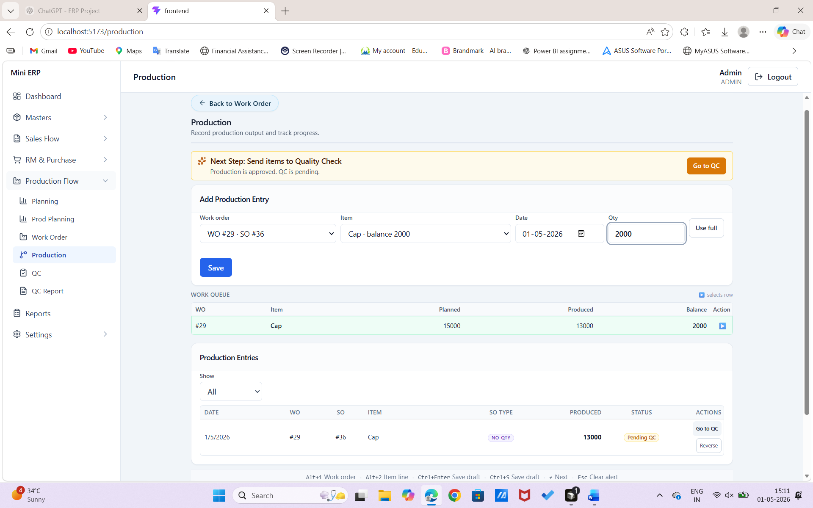
Why dispatch full, prepare dispatch & use max headroom? When to use “use from stock”?
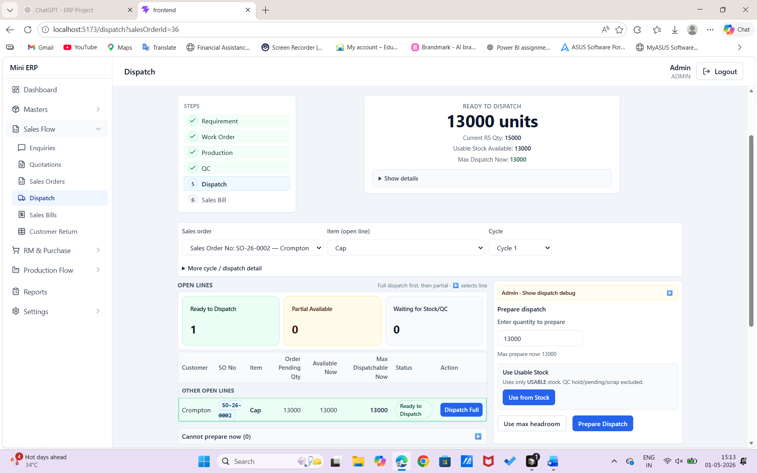

After dispatch where is Next Step - Sales Bill
